**PROJECT SPECIFICATION**

**Group II (Rubber Ducks): Socratis Katehis, Tarekul Islam, Daniel Obeng, Maureen Hanna, Miguel Rodriguez**

**INTRODUCTION**

Deception detection has been a widely researched field in many different industries. Typical lie detectors used what are called contact receivers to analyze information like heart rate, skin conductivity, sweat response, and blood pressure. With the increased sophistication and accessibility of artificial intelligence throughout the technology realm, we will attempt to apply multiple techniques to create a non contact method of deception detection. Using multi-modal data like facial micro-expressions and voice analysis with machine learning techniques, we will attempt to produce a correlation between facial and vocal features and deceptive acts to determine, to some degree of accuracy, whether someone has committed an act of deception.By interviewing candidates and asking them to provides answers questions we already know the answers to, it is our goal to train our software to anticipate whether a subject is lying based on stress indicators such as: pupil dilation, head motion, eye blink rate, gaze direction and voice stress levels.

Such as system is necessary, because there is a need for non-invasive methods to detecting deceptive behavior. We aim to combine head movement, facial micro-expressions, eye blink patterns, and voice amplitude/frequency to detect deceptive behavior. These behaviors that we measure are ones that are subconsciously activated. This allows us to have measurements that we can actually use without worrying about subject having power over his reaction to a stimuli. Furthermore our invasive techniques allow us to measure a subject without affecting his normal behavior. Invasive techniques remove a subject from his/her normal behavior because it affects their physiological behavior. Such a system can be used in criminal investigations, suspect questioning and any area where detecting deceptive behavior is necessary.

**BACKGROUND**

Deception detection has become a budding area of research in recent years. Currently, there are several accepted methods used by various entities to try to predict when a deceptive behavior has occurred. The most commonly known deception detector is the polygraph test. The Polygraph uses a physiological approach to lie detection by measuring factors such as heart rate, respiratory rate, skin conductivity and blood pressure to determine a subject’s deception. It relies on the theory that lying is stressful, so a spike in a person’s stress indicators would indicate an act of deception. However, the Polygraph requires the subject to be strapped with special equipment for measuring the above mentioned parameters, which isn’t easily accessible and sometimes tedious to administer. Moreover, due to the invasive nature of this test (the fact that the subject is aware that he is being monitored), there is a high probability of false positives due to the natural nervousness of some when they know they are being monitored. On the other hand, people can learn to relax themselves during such tests, and such as suppress the triggers that would normally indicate deception. As a result, many are moving away from this test and it is rarely used in criminal tests due to these factors.

Another method that have been to detect deception is Brain Activity analysis. Scientists have proved recently that the center of lying is the frontal lobe; significant activity occurs in this area when a person lies or make errors. Special imaging devices can be used to measure this activity to determine whether a subject is lying. This method also suffers similar limitations as the Polygraph test and requires special equipment that are expensive and not readily accessible.

We propose a system that will use readily accessible devices (high quality cameras and a high processor computer) to detect deception by non-invasively monitoring involuntary behaviors that have been proven by psychological research as indicative of an attempt to deceive. The relevant parameters, as confirmed by psychological research, are listed below:

1. **Pupil Dilation:** Relatively conclusive indicator of a person lying. Enlarged pupils indicate that the brain is working hard which is how a lie can best be executed.
2. **Blinking Rate:** Normal blink rates average about 20 times/minute. Interestingly, blink rate slows while a person is telling a lie and rapidly increases after they have completed the lie (up to four or five times that of normal blinking average)
3. **Gaze Direction:** the liar averts gaze when lying
4. **Voice Modulation:** The intensity, amplitude or the strength of the voice modifies as well as the voice pitch increasing beyond normal reported pitch.

**SYSTEM DESCRIPTION**

As indicated earlier, our system will use multi-modal data from face and voice along with machine learning techniques to determine, to some degree of accuracy, whether someone has committed an act of deception. Our system will operate in two phases, the *control phase* and the *critical phase*. During the control phase, we will ask the subject baseline questions (questions that will produce answers that are true) and establish the normal behavior of the subject. We’ll train our system with the data obtained in the phase. During the critical phase, we’ll ask the subject questions that are likely to elicit a deceptive response and determine (in comparison to the normal behavior of the subject) whether a lie is being told.

Below, we provide a detailed description of the specific parameters we’ll be measuring and how we’ll be measuring them.

**1. Facial Micro-Expressions**

Facial Micro-Expressions are involuntary facial changes (micro movements) that are not discernable to the human eye. This is because they occur in short time interval, usually in a few milliseconds (approximately 1/25th of a second). There are eight basic facial expressions that can be exhibited by the human face. These are anger, contempt, disgust, fear, happiness, joy, sadness, surprise and neutral. An expression that is exhibited by a subject only in a few milliseconds is classified as a micro-expression.

Research indicates that if a subject exhibits a micro-expression during an interrogation or similar activity, it is a strong sign of an attempt to hide something (i.e in our case, a lie)

***Implementation***

1. Capture an HD quality video conservation of participant at at least 25 FPS
2. Video is broken into its frames (25 frames for every second of recording)
3. Each frame is tagged with an expression and a time
4. If the same expression is repeated less than five times consecutively, it is marked as a micro-expression (which signifies that the person could be trying to hide something)
5. Programs outputs time where micro-expression occurs, indicative of the time lying

NOTE: System learns patterns of expression during the control phase for better predictability during the critical phase

**2. Eye Blink Patterns**

Research shows that eye blinking rates decrease when there is an increase in cognitive demand. Lying is more cognitively demanding than telling the truth. This is because while lying, a person is conscious that their lie may or may not be observed by the onlooker as a lie and must cognitively consider all the various scenarios that must be addressed in order for their lie to be believed.

Blink rate of the participant is measured in a target period and compared with the normal blink rate of the person (determined during the control phase and set as the threshold value). If the subject is lying, there will be a major decrease in the blink rate during the lieing period as compared to the threshold value, followed by a significant increase in the blink rate above the threshold value, once the lie has been told.

Alternatively, if the blink rate showed very little variation from the threshold value during the entire process, it is concluded that the person is telling the truth.

***Implementation***

1. Take a high speed video of conversation (about 60FPS)
2. Video is broken into its respective frame
3. Frames are categorized into periods
4. For each frame, determine whether eyes are closed or open.
5. Determine blink rate for the period.

**3. Gaze Direction**

According to behavioral scientist’s eye movements(gaze aversion) is good indicator of inner emotions or when a person tells a “high stake” lie. For example, averting eye contact might show a lie or a person feeling shame. In a high stake lie, a lie is readily more detectable than a low stake lie. According to Dr. Paul Ekman, a psychologist, recommends looking at the eyes and the upper half of face to detect deceit. One would also logically infer that research of gaze direction would be rigorously documented. And yet, concrete results have been illusive. One problem that arises for researchers is the fact that the eyeball is not a perfect sphere, nor is it a solid specimen. This makes monitoring changes in position a difficult undertaking. To further compound the problem, pixelation of changes cannot be relied upon because radial measurements are inconsistent.

Nonetheless, we will attempt to map fluctuations in gaze direction by focusing on “high stakes” lies. Heightened emotional states are reached when someone has much to lose or gain by executing a good lie. Correspondingly, gaze direction will be more exaggerated and therefore easier to map. We aim to train an automated and dynamic machine to detect eye movement in a conversation during a “normal” course of conversation for each subject. The remaining conversation(critical period) after training the machine is broken down and compared against the parameters of behavior the machine has learned from earlier conversation(baseline period).

***Implementation***

1. Take a high speed, high quality video of the conversation (about 30fps)
2. Break video into its respective frames
3. Initialize eye regions in the first frame and subsequently track using an incremental learning tracker
4. Locate and record the relative x-y coordinates of the centroid of the pupil in relation to white space of eyeball for all frames
5. Training step, monitor pupil vs white space of eyeball under normal baseline behavior.
6. During the critical step, determine level of eye aversion and test against baseline behavior
7. If subject deviates from normal behavior, it is a strong indication of deception.

**4. Voice Modulation**

Deception detection is primarily based on heart rate increases, stress measurement and brain activity. Under stress, muscles that control the respiratory system are affected. The process of speech production changes as a result. Pitch variation, the higher concentrated frequency bands of energy, the speak rate and voice intensity all increase to signify a heightened stress state.

In order to assess vocal changes (pitch and intensity), we will track frequency spikes during intervals coinciding with our question/answer data inputs.

ALGORITHM / IMPLEMENTATION

1. Compute the MFCC (Mel Frequency Cepstral Coefficient from the speech signal)
2. Extract the pitch of the voice. Measure the pitch variation over time (The increase of the standard deviation, mean value and/or the range of pitch and decrease of pitch jitter is ranked as a stress indicator)
3. Computer FFT and IFFT to extract data with few outliers.
4. Analyze pitch contour and pitch amplitude, since they have the highest correlation to deception.

We will attempt to follow the research provided by the National Defence Center of the Egyptian Armed Forces. Below is an incredible FSM that generalizes the process that we would recreate.

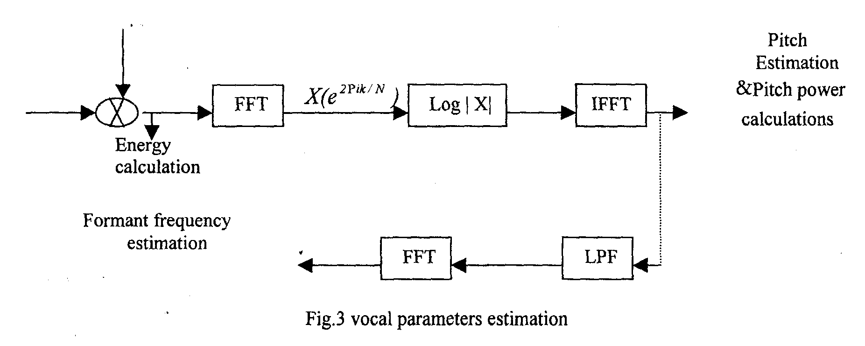

Our goal is to layer all the above methods and train a system that will use them to determine whether a lie is being told during an interrogation.

**MEMBER RESPONSIBILITIES**

During the development of this system, we will assume the following responsibilities:

***Socratis Katehis:*** Project Manager

***Daniel Obeng:*** Product Manager

***Miguel Rodriguez:*** Developer

***Maureen Hanna:***

***Tarekul Islam:*** Developer

**CONCLUSION**

Our goal is to develop a system that will be able to predict with some accuracy whether a subject being interrogated is lying or not. We’ll combine data from video and voice to achieve this by measuring factors that are, according to psychological research, indicative of a subjects attempt to lie.

Since we’ll be getting most of our data from video and voice by tracking features of the subject’s face and voice respectively, we anticipate that we’ll face the general issues involved with audiovisual systems. These include background noise, poor lighting, out of focus video, and subject’s poor head orientation (head orientation could inhibit face/eye tracking). We endeavor to avoid these issues by performing our system tests in an enclosed indoor environment with little to no background noise. Also, we’ll use an HD quality high speed camera (at least 30FPS) in a well lit room with the subject facing directly at the camera (Camera will likely be hidden to eliminate any observer effects).

**REFERENCES**

1(2003) DePaulo, B.M. et. al. 2003. Cues to Deception. *Psychological Bulletin, 129 (1),* 74-118.

2 (2015). Nojie and Malutan “Head Movement Analysis in Lie Detection”.Technical University of Cluj-Napoca, Communications Department, Cluj-Napoca, Romania.

3 (2012) Milán and Salazar López “Demuestran el ‘efecto Pinocho’: cuando una persona miente, cambia la temperatura de la punta de su nariz”Departamento de Psicología Experimental. Universidad de Granada, Spain.

4 (2007).[Yoshima and Ohmoto ”Discrimination of Lies in Communication by using Automatic Measuring System of Nonverbal Information”](http://ieeexplore.ieee.org/search/searchresult.jsp?searchWithin=%22Authors%22:.QT.Yoshimasa%20Ohmoto.QT.&newsearch=true) Department of General Systems Studies, University of Tokyo, Tokyo, Japan.